WEEK – 3 Assignments
Entity Framework Core 8. 0
Mandatory hands-on :-
Lab 3: Using EF Core CLI to Create and Apply Migrations
Scenario:
The retail store's database needs to be created based on the models you've defined.
You’ll use EF Core CLI to generate and apply migrations.
Objective:
Learn how to use EF Core CLI to manage database schema changes.

1. Install EF Core CLI (if not already)

dotnet tool install --globai dotnet-ef
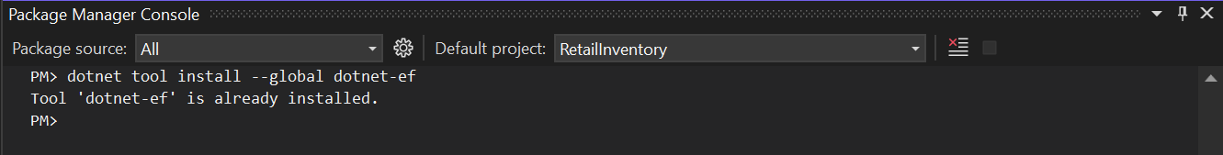
2. Create Initial Migration

dotnet ef migrations add InitialCreate
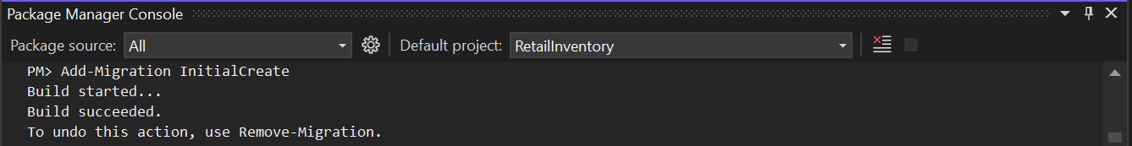

3. Apply Migration to Create Database:

dotnet ef database update
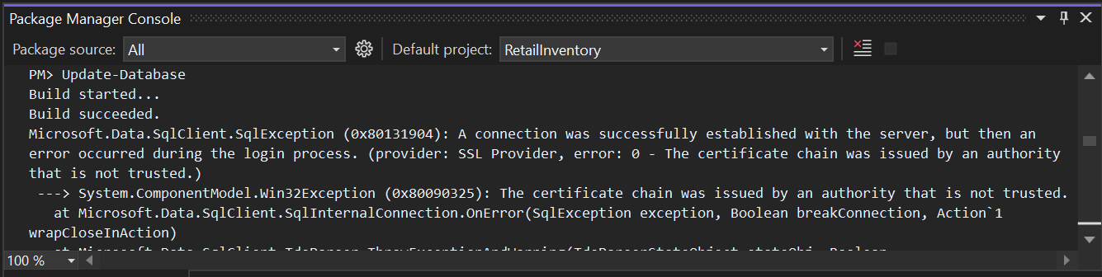

4. Verify in SQL Server:
